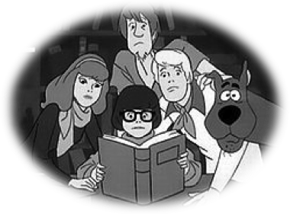

An evening of fun for the whole family
as we present a fall festival and
Scooby-Doo classic short from 1978

Sunday, October 18th
4:00 to 7:00 p.m.
Wea Creek Orchard, 5618 S 200 East


- $5.00 per person – sold at the gate (children 2 and under free) Groups of more
than four, $3 per person. Cash or check only.

- Costumes are encouraged! Lots of pumpkin and apple activities in conjunction
with Purdue Collegiate FFA! Pumpkin seed spitting contest, HAYRIDES,
prize baskets, crafts and more!

- Concessions will be available for purchase. Emergency Munchie Truck on site!

- Activities begin at 4, movie starts at 6:30.

- Proceeds benefit ALL public schools in Tippecanoe County.

- For more information and to register - visit www.psftc.org.


Sponsored by: Wea Creek Orchard


Don’t forget to wear your costume

